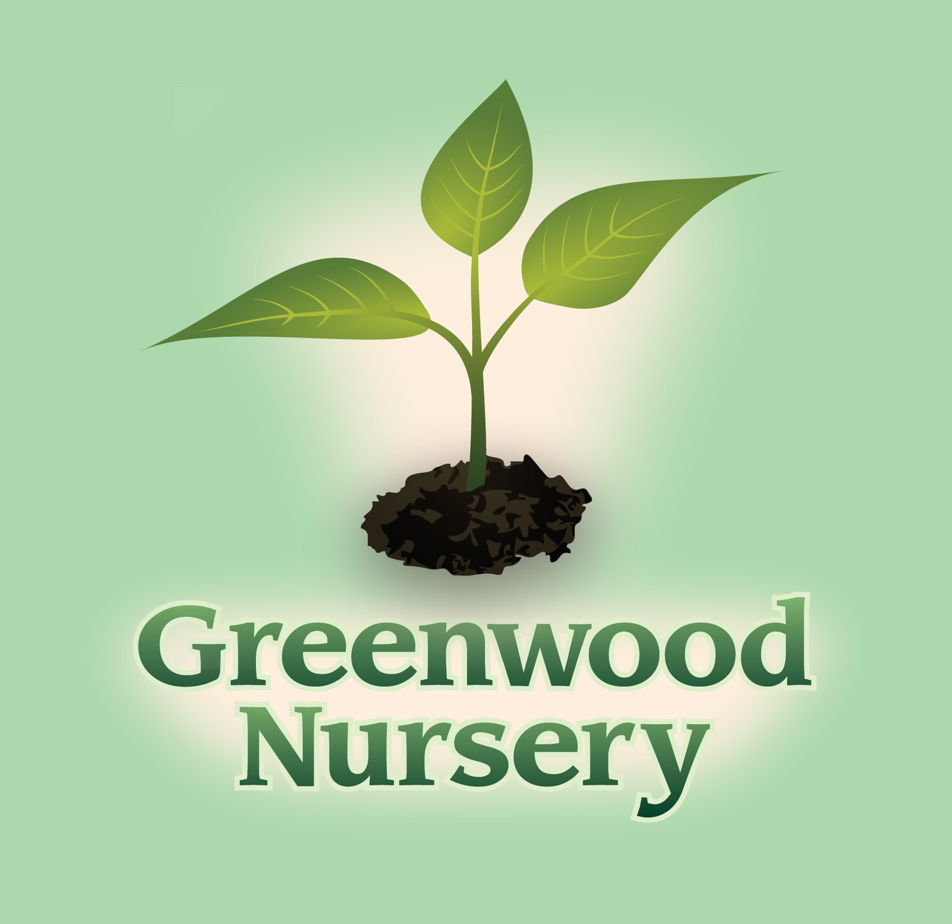

Apple Trees and Pollination

In order to have a successful apple harvest, all trees need to have a second tree as a pollinator. Apple trees should be planted at least 15 feet apart.

TRACY STORE
611 S. 4th Street Tracy, MN 56175
507-629-3485
MARSHALL STORE
2705 County Road 6 Marshall, MN 56258
507-532-9430
Apple Tree Variety | Pollination and Ripening | About the Apple
Chesnut Crab | Early to mid-September | Small, sweet, and crisp, great for eating
Connell Red | Cannot pollinate Fireside  Mid-October | Large red fruit, excellent for eating, cooking, and keeping
Fireside | Cannot pollinate Connell Red  Mid-October | Large red fruit, good for eating and storing.
Haralred | Cannot pollinate Haralson  Late September to early October | Juicy, tart, good keeper
Honeycrisp | Late September | Crisp, juicy, great keeper, sweet
Honeygold | Early to mid-October | Medium to large yellow fruit, crisp, juicy, sweet, good for cooking and eating. Medium storage life
Red Baron | Late September | Medium sized, red/yellow fruit, crisp, juicy, sweet, good for eating and cooking
Red Regent | Early October | Medium to large red fruit, juicy, crisp, sweet and tart, good excellent for eating and cooking
State Fair | Mid to late August | Medium sized red fruit, good for eating and cooking. All purpose apple.
SnowSweet | Mid to late September | Sweet but a little tart
Sweet Sixteen | Mid to Late September | Medium sized red fruit, crisp, sweet. Great dessert apple.
Wealthy | Mid-September to early October | Red fruit, tart but balanced flavor, Great for cooking and eating
Zestar | Mid to late August | Sweet and tart flavor, excellent for cooking

TRACY STORE
611 S. 4th Street Tracy, MN 56175
507-629-3485
MARSHALL STORE
2705 County Road 6 Marshall, MN 56258
507-532-9430

