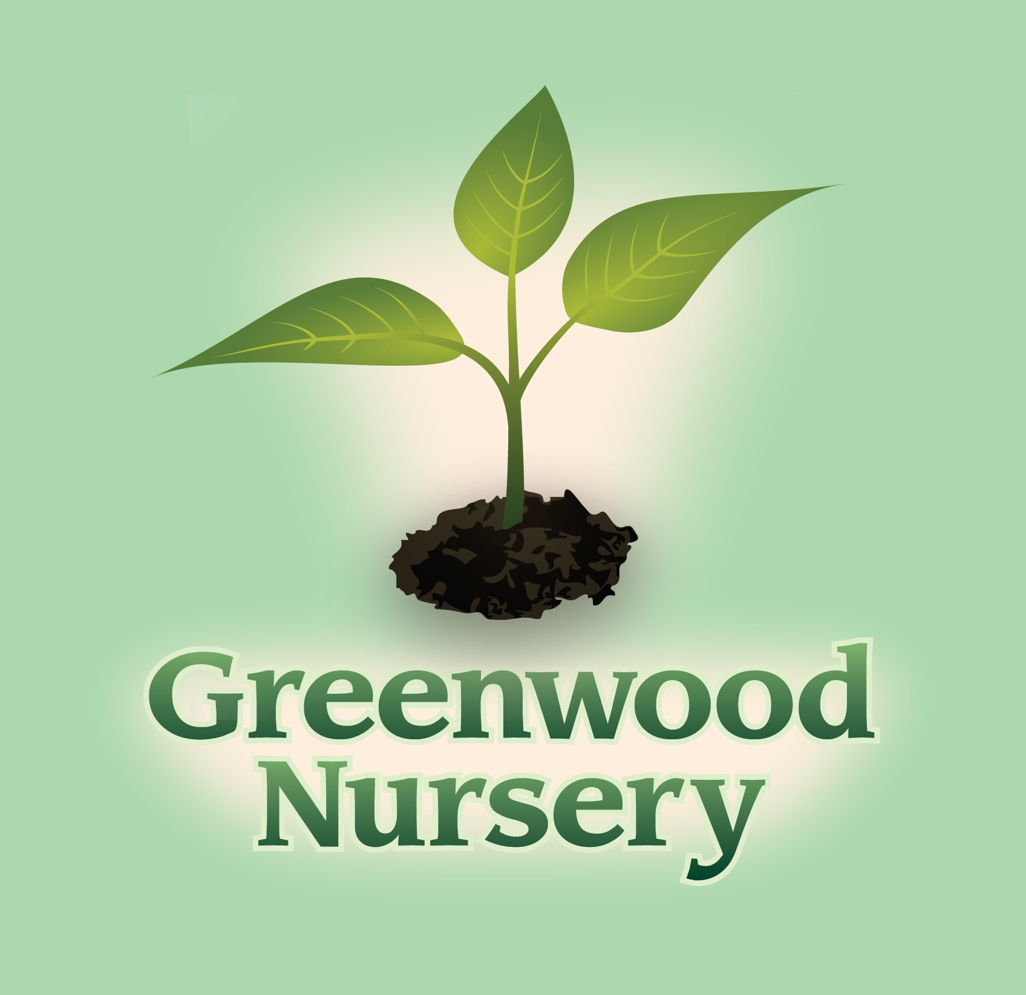

Deer and Rabbit Resistant Plants

When deer do damage to ornamental plants it is very frustrating. You can minimize the damage they do by avoiding plants they prefer and use the plants listed below which they tend to avoid due to fragrance or texture.

Perennials and Bulbs | Annuals
Achillea - Yarrow | Begoniaceae - Begonia
Allium | Lobularia maritime - Alyssum
Aquilegia - Columbine | Pelargonium - Geranium
Echinacea - Coneflower | Senecio cineraria - Dusty Miller
Narcissus - Daffodil | Tagetes - Marigold
Paeonia - Peony | Trees, Shrubs, and Vines
Papaver - Poppy | Berberis - Barberry
Perovskia - Russian Sage | Celastrus scandens - Bittersweet Vine
Salvia | Oleaceae - Forsythia
 | Pinus mugo - Mugo Pine
 | Syringa - Lilac

TRACY STORE
611 S. 4th Street Tracy, MN 56175
507-629-3485
MARSHALL STORE
2705 County Road 6 Marshall, MN 56258
507-532-9430

