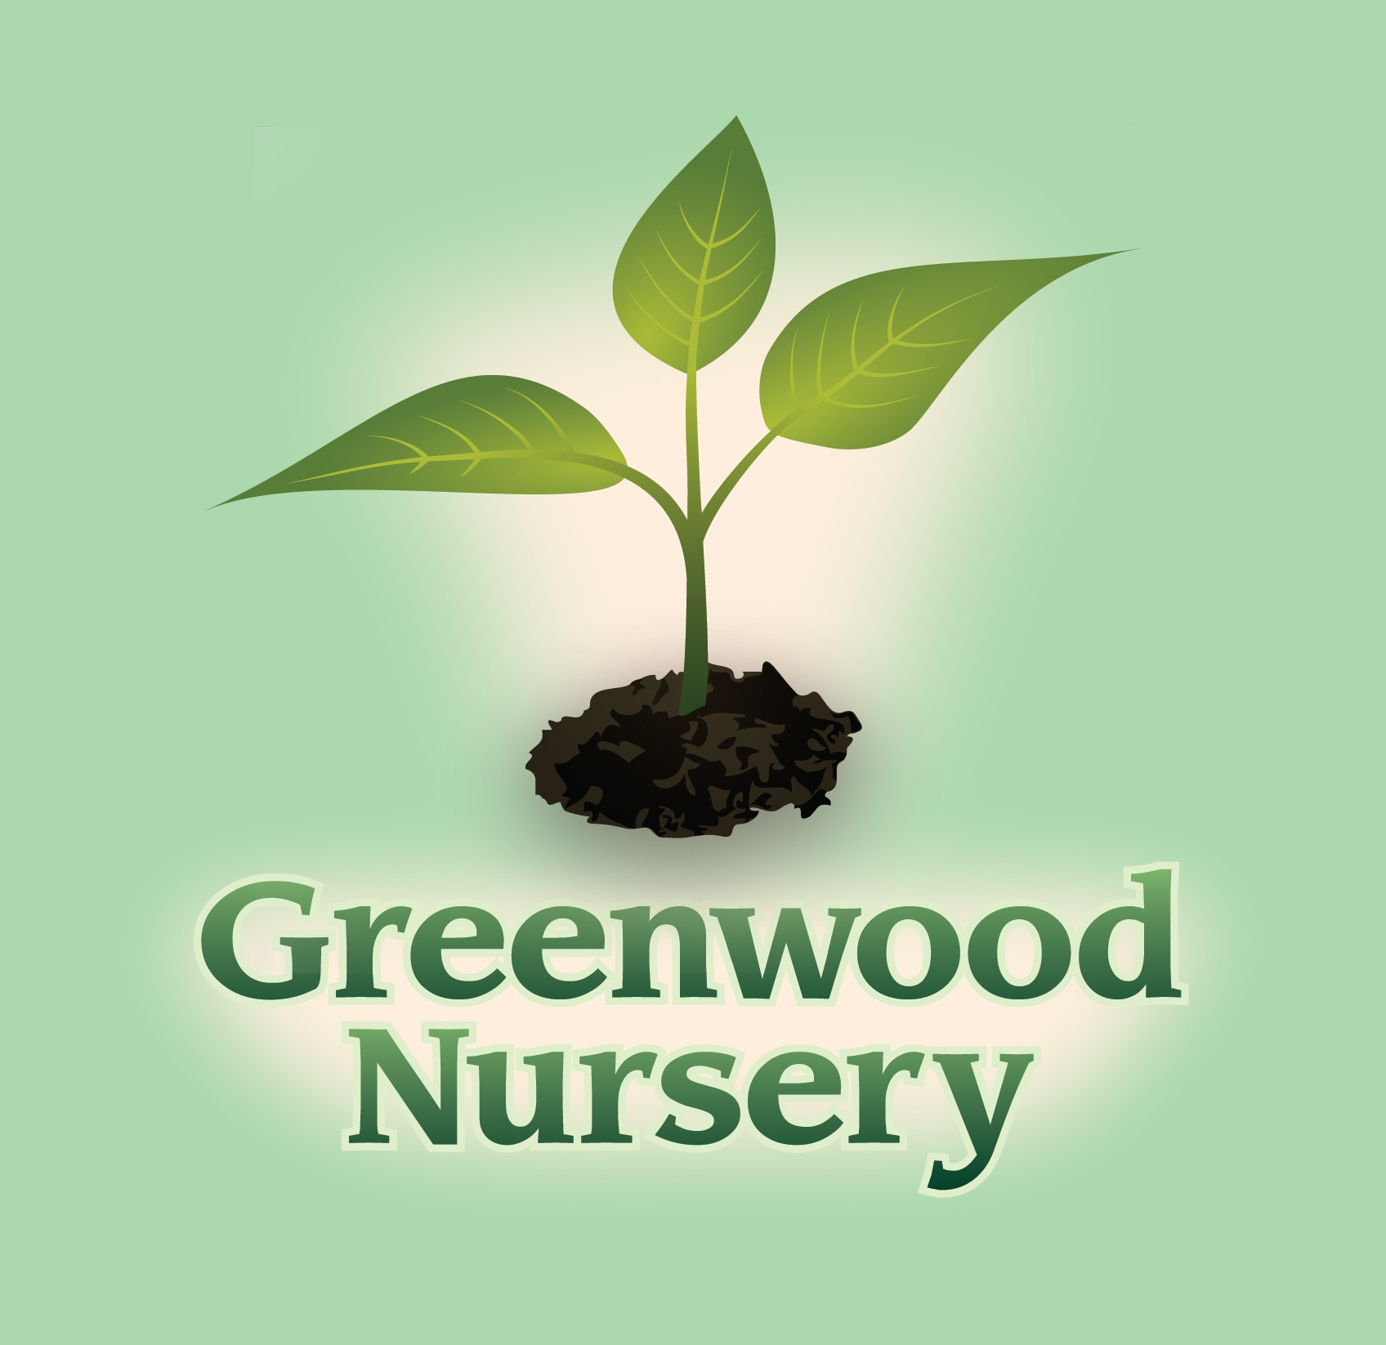

Plants with Fall Color

Trees | Shrubs
- Purple  - Burr Oak | - Purple  - Red Twig Dogwood  - Royal Purple Smokebush
- Red  - Autumn Blaze Maple  - Firefall Sugar Maple  - Sugar Maple  - Pin Oak  - Oak Leaf Mountain Ash | - Red  - Amur Maple  - Ruby Carousel Barberry  - Rosy Glow Barberry  - Compact American Cranberrybush  - Magic Carpet Spirea  - Goldflame Spirea  - Peking cotoneaster  - Dwarf Burning Bush
- Yellow  - American Linden  - Shamrock Linden  - Gleneven Linden  - Skyline Locust  - Sunburst Locust  - Emerald Lustre Norway Maple  - Quaking Aspen  - Ginkgo  - Weeping Willow  - Prairie Dream Birch  - Kentucky Coffee Tree | - Scarlet  - Renaissance Spirea  - Smooth Sumac  - Tiger Eyes Sumac  - Golden Carousel Barberry  - Yellow  - Bud’s Yellow Dogwood  - Alpine Currant

TRACY STORE
611 S. 4th Street Tracy, MN 56175
507-629-3485
MARSHALL STORE
2705 County Road 6 Marshall, MN 56258
507-532-9430

