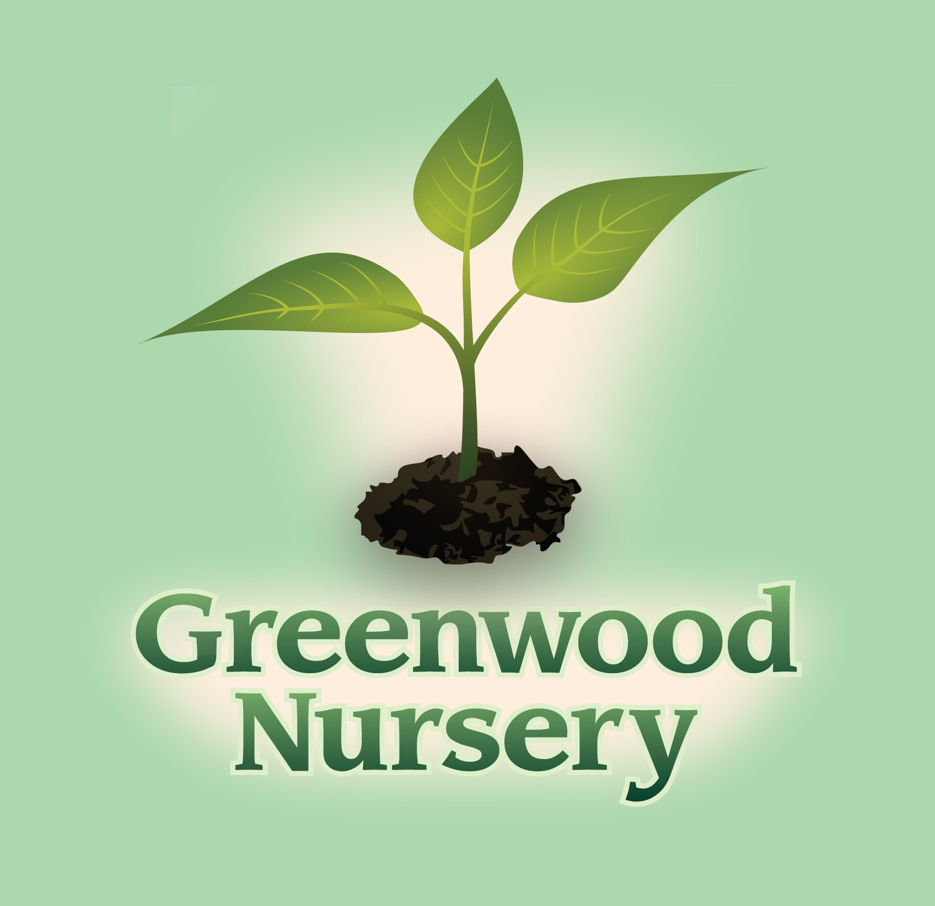

Plants that Attract Hummingbirds

Perennials | Annuals
Alcea – Hollyhock | Antirrhinum – Snapdragon
Aquilegia – Columbine | Begoniaceae – Begonia
Asclepias tuberosa – Butterfly Weed | Cleome – Spider Flower
Delphinium | Dahlia
Dianthus – Carnation | Dianthus – Carnation
Heuchera – Coral Bells | Impatiens
Hibiscus | Mirabilis – Four O’Clocks
Lilies | Pelargonium - Geranium
Lobelia – Cardinal Flower | Petunia
Lupinus – Lupine | Zinnia
Monarda – Beebalm | Trees, Shrubs, and Vines
Nepeta – Catmint | Caprifolium – Honeysuckle Vine
Penstemon – Beard Tongue | Campsis radicans – Trumpet Vine
Phlox | Cotoneaster
Physostegia – Obedient Plant | Crataegus – Thornless Cockspur Hawthorn
Salvia | Fruit Trees
 | Malus – Flowering Crab
 | Syringa – Lilac
 | Weigela

TRACY STORE
611 S. 4th Street Tracy, MN 56175
507-629-3485
MARSHALL STORE
2705 County Road 6 Marshall, MN 56258
507-532-9430

