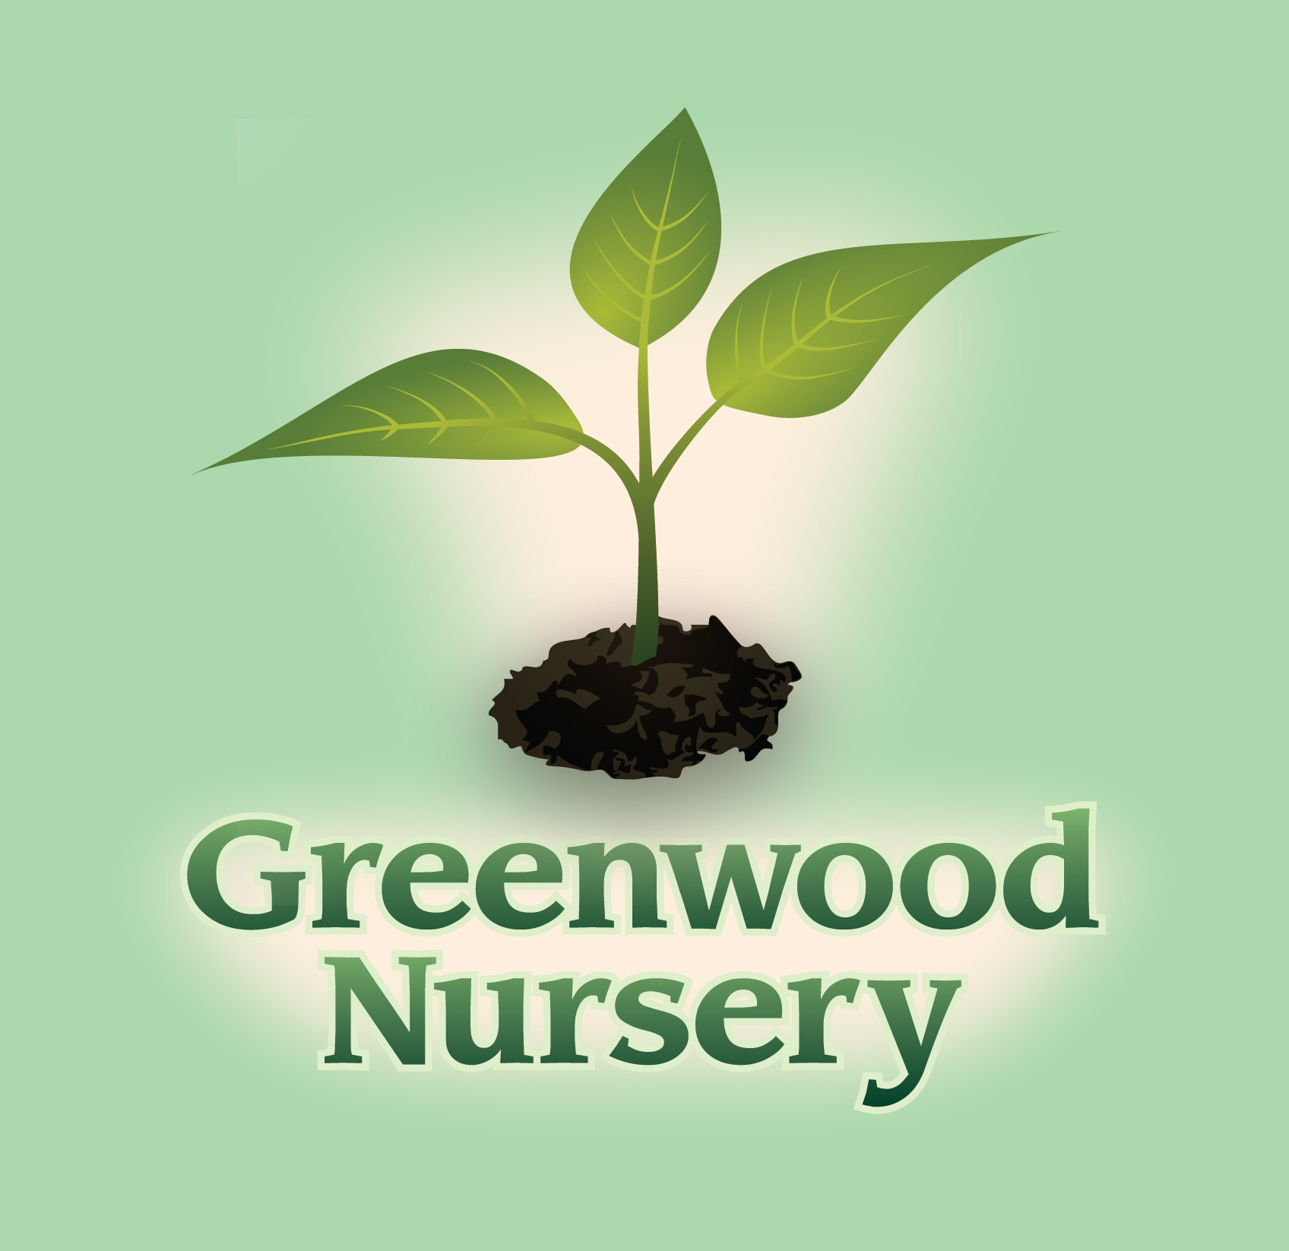

Plants that are Fragrant

Perennials and Bulbs | Annuals
Centaurea – Bachelor Button | Dianthus
Convallaria – Lily of the Valley | Ipomoea alba – Moonflower
Eupatorium – Joe-Pye Weed | Lathyrus – Sweet Pea
Monarda – Bee Balm | Lobularia maritime - Alyssum
Nepeta – Catmint | Petunia
Oenothera – Primrose | Pelargonium - Geranium
Paeonia – Peony
Perovskia – Russian Sage | Shrubs and Vines
Phlox | Mockorange
Polygonatum – Solomon’s Seal | Celastrus scandens - Bittersweet Vine
Trees | Oleaceae - Forsythia
Crataegus – Hawthorn | Rosa – Roses
Fruit trees | Syringa – Lilac
Hydrangea – Hydrangea Tree | Honeysuckle Vine
Malus – Flowering Crab Tree | Wisteria Vine
Syringa – Lilac Trees | Clematis Vine

TRACY STORE
611 S. 4th Street Tracy, MN 56175
507-629-3485
MARSHALL STORE
2705 County Road 6 Marshall, MN 56258
507-532-9430

